PACKET TRACER SIMULATION DOCUMENTATION

1.1)

Description | Network
Developers Domain | 192.168.0.0/28
DHCP server | 192.168.0.10/28
Central DNS Server | 192.168.0.13/28
Users | DHCP Server issuing ten IPs from 192.168.0.5/28
Default-Gateway | 192.168.0.1/28
Gateway of Last resort (Loopback) | 41.0.0.1
Business Analyst Domain | 192.168.0.32/27
DHCP server | 192.168.0.35/27
Central DNS Server | 192.168.0.13/28
Users | DHCP Server issuing twenty IPs from 192.168.0.40/27
Default-Gateway | 192.168.0.33/27
Gateway of Last resort (Loopback) | 200.1.1.1/32
Active Route between Business Analyst & Shared Router via S0/3/1 | 192.168.0.84/32
Backup Route between Business Analyst & Shared Router via S0/2/0 | 192.168.0.128/32
Second Floor
Test Engineers VLAN 10 | 192.168.0.64/28
UI-Designer VLAN 20 | 192.168.0.96/28
Shared Resources VLAN 30 | 192.168.0.112/28
Third Floor
Network | 192.168.1.0/24
Web Server | 192.168.1.14/24
System Log server | 192.168.1.3/24
Staging Environment Server | 192.168.1.10/24
Default-Gateway | 192.168.1.1/24
Gateway of Last resort (Loopback) | 203.0.113.1/32

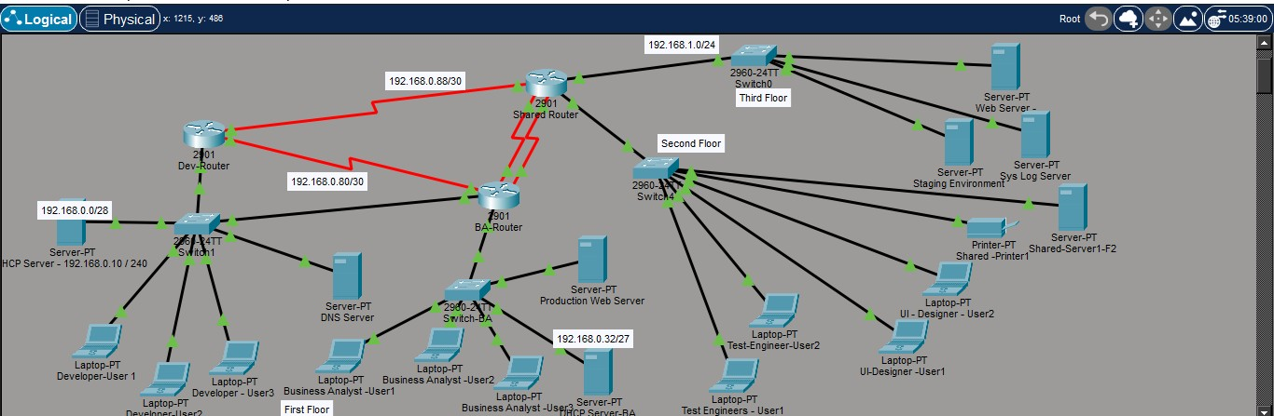

1.2)

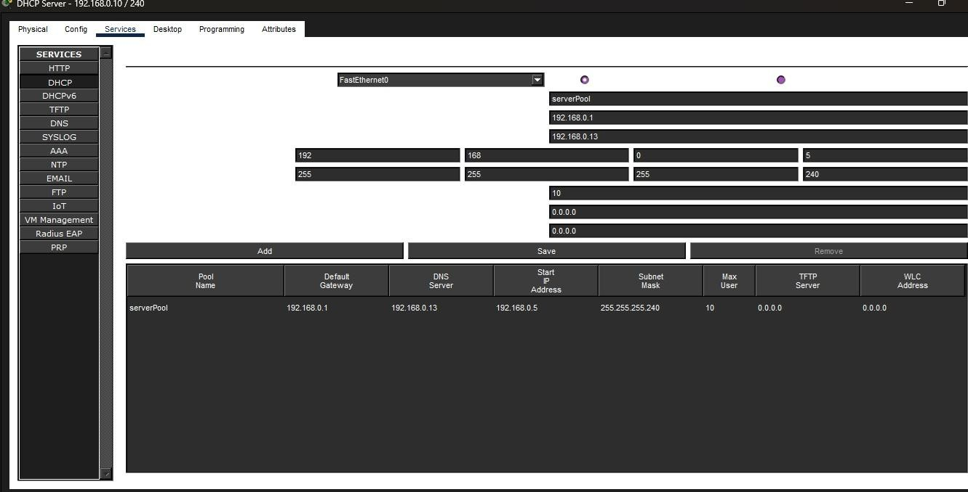
DHCP Server settings.

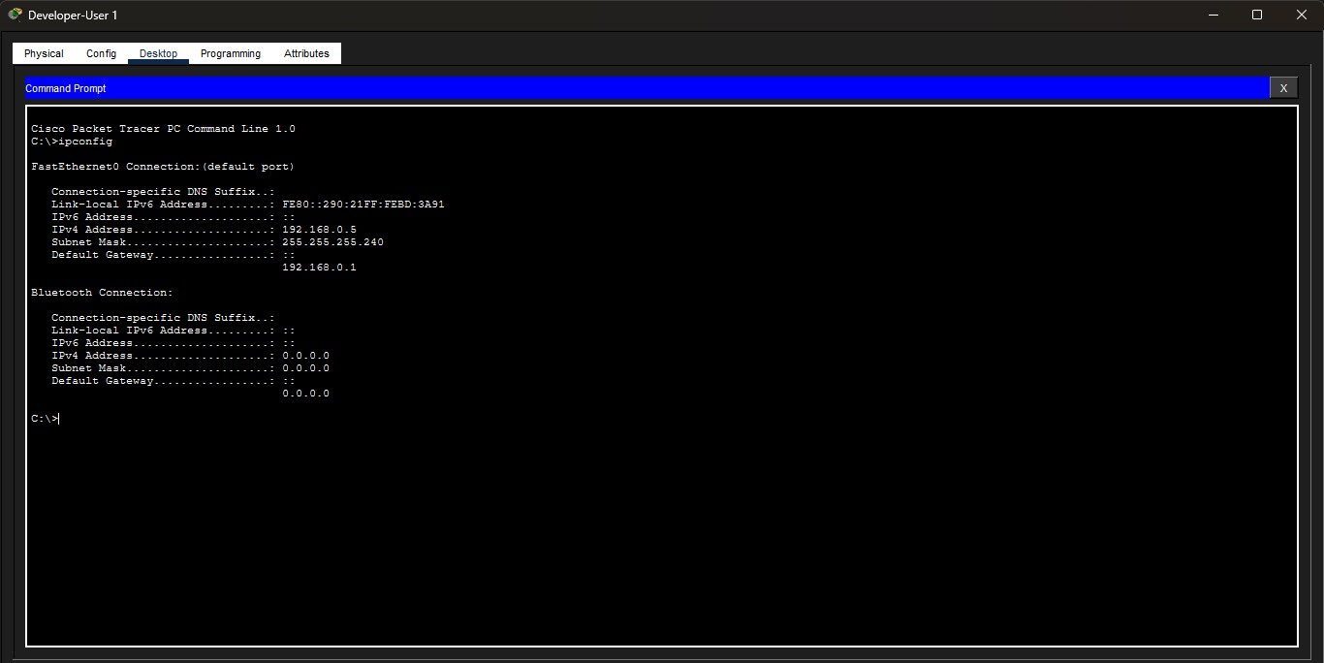

Developer PC User 1 Testing DHCP functionality.

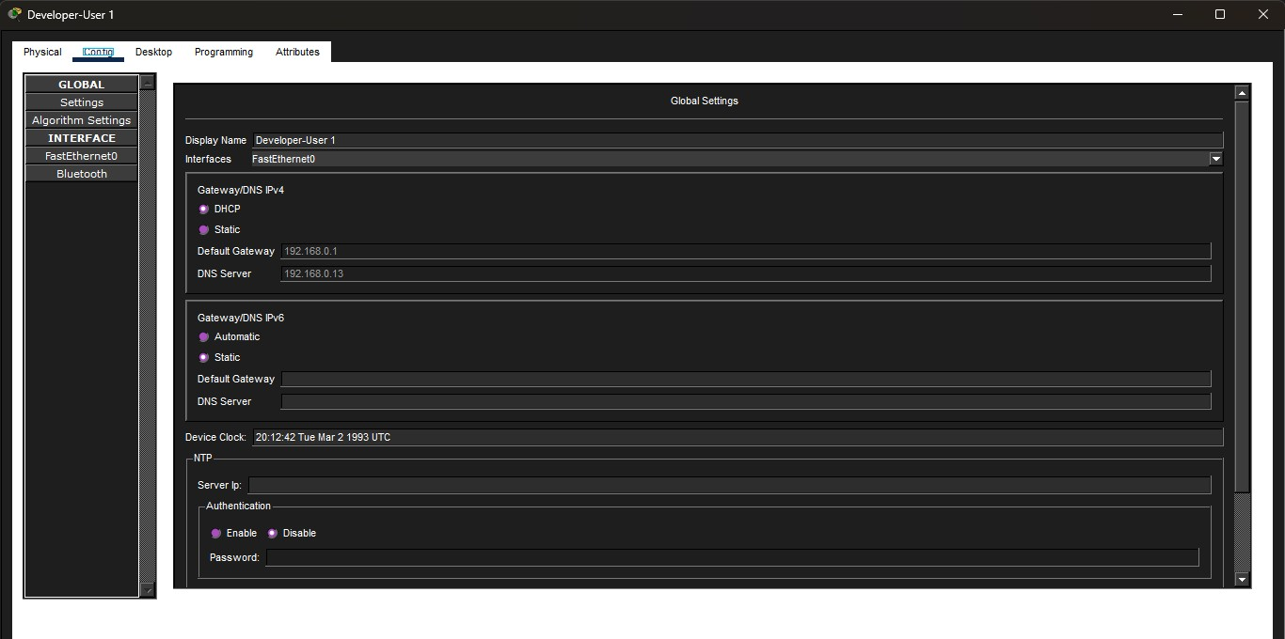

DHCP server functioning on the developer department

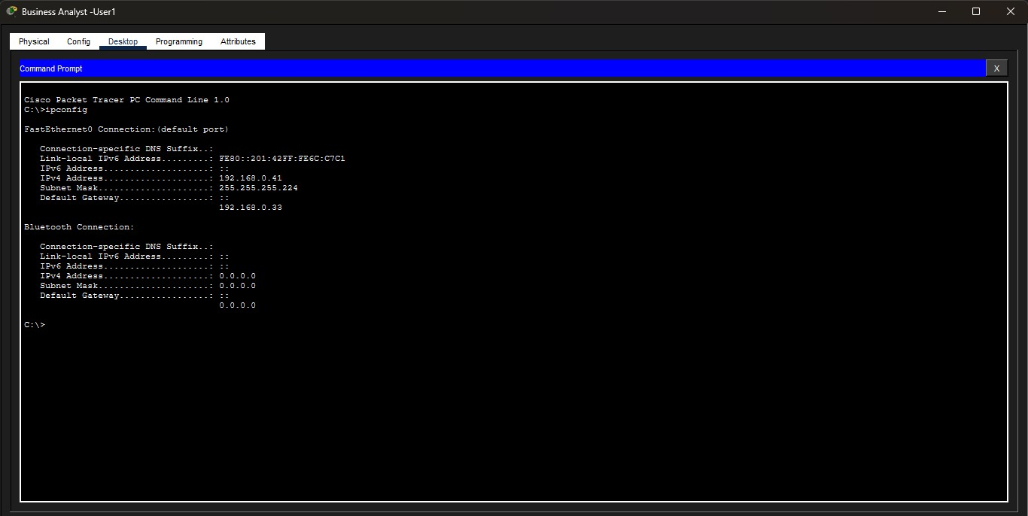

Business Analyst PC showing DHCP server is functioning on their department.

DNS Server settings

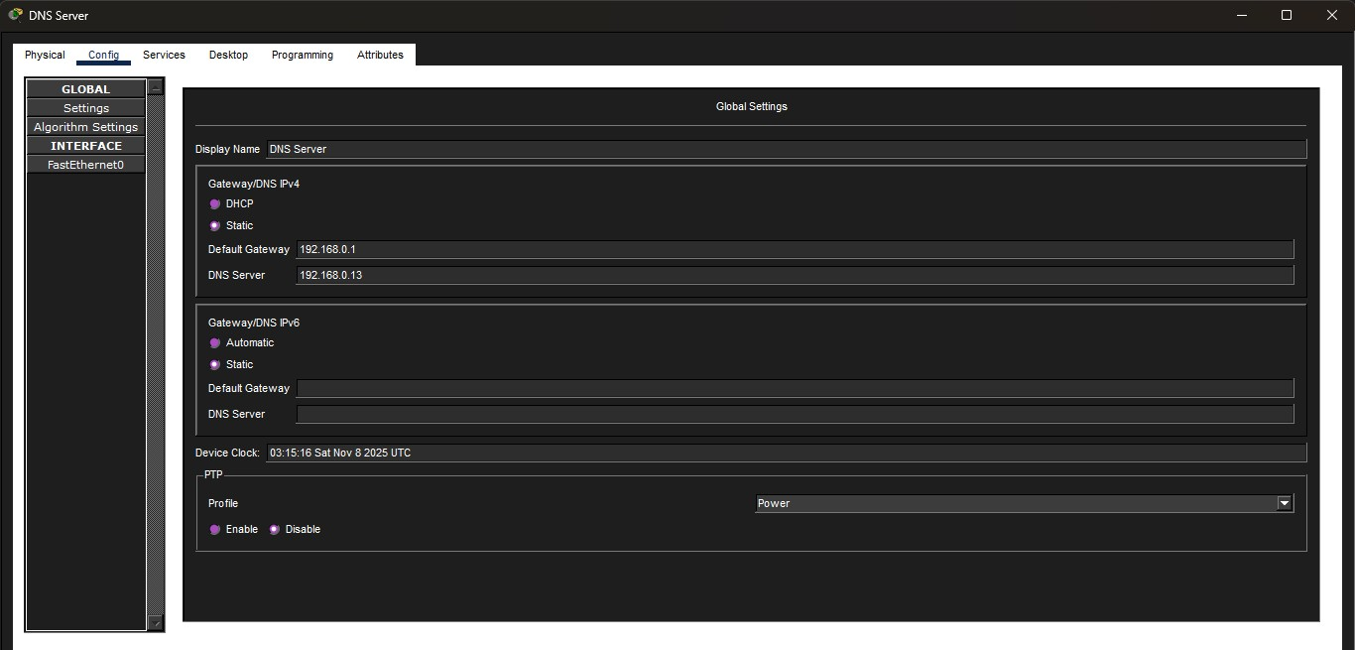

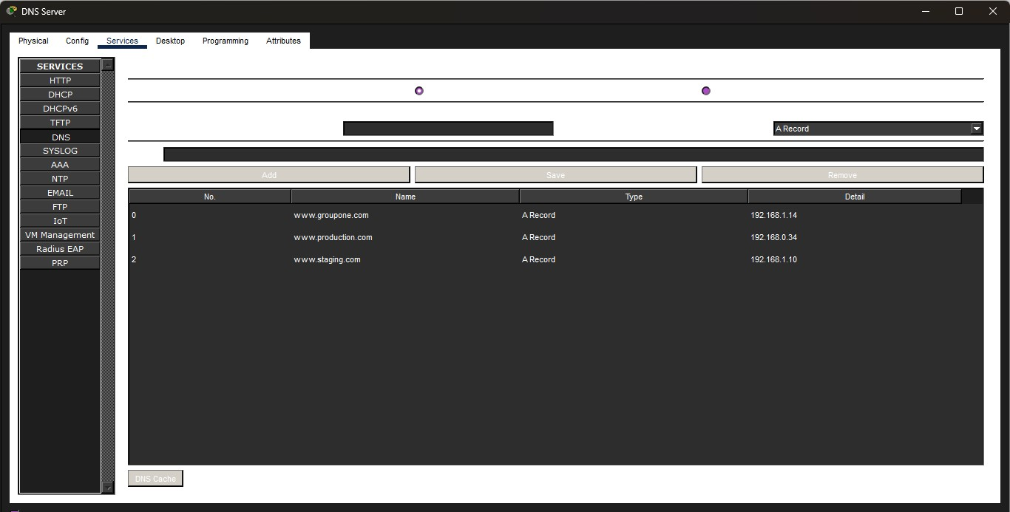

1.3)

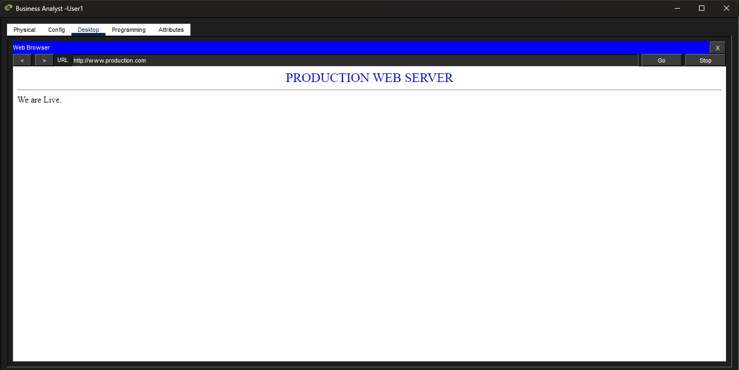

Business Analyst users are able to access the production web server via the url :
http://www.production.com, proving that the DNS server is functioning as seen above.

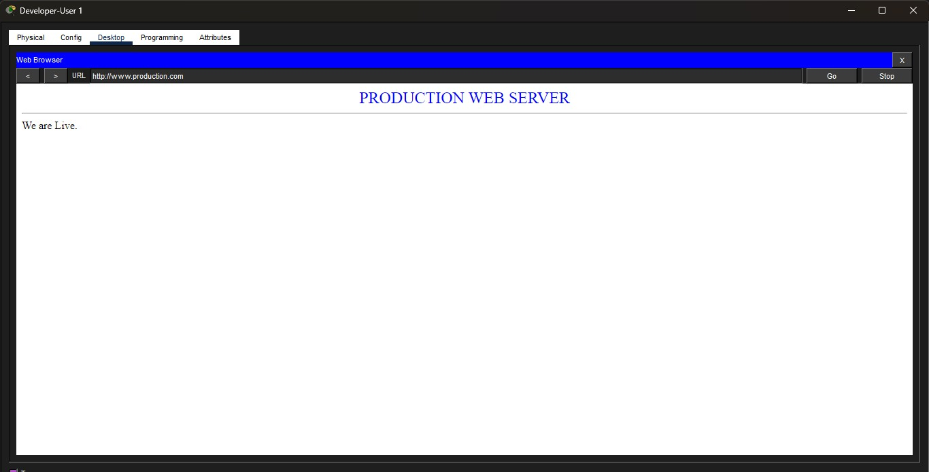

Developer users are able to access the production web server via the url :
http://www.production.com, proving that the DNS server is functioning as seen above.

2.1)

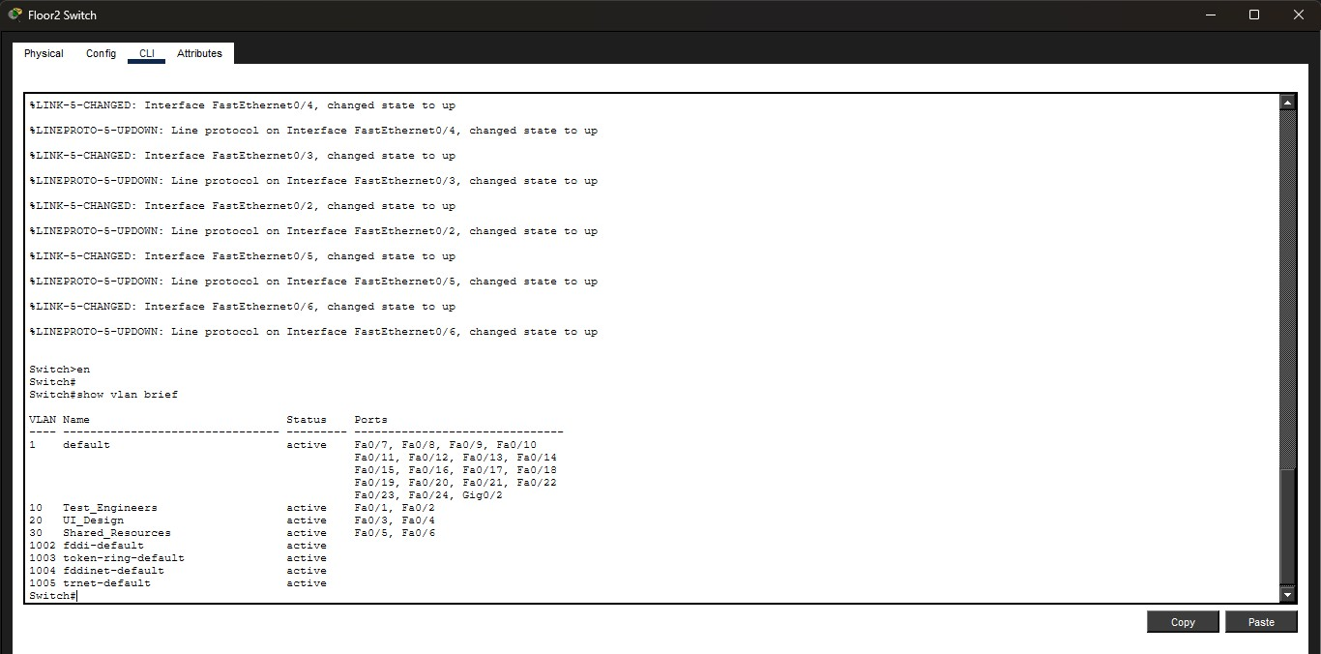

Vlan 10 for Test Engineers, Vlan 20 for UI Designers and Vlan 30 for shared resources was created and switch port assigned to respective Vlans as shown above.

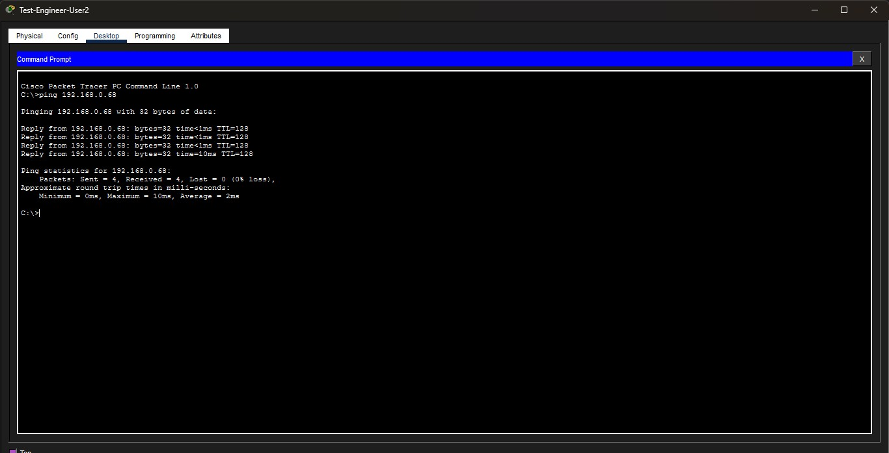

Test engineers can communicate in their domain

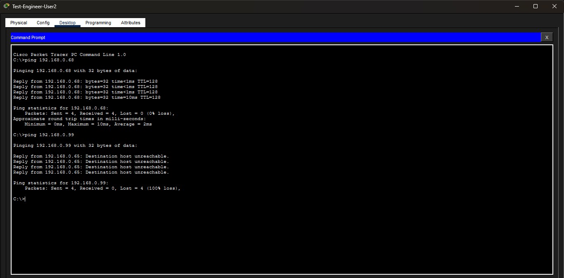

Test engineers cannot communicate with UI Designers.

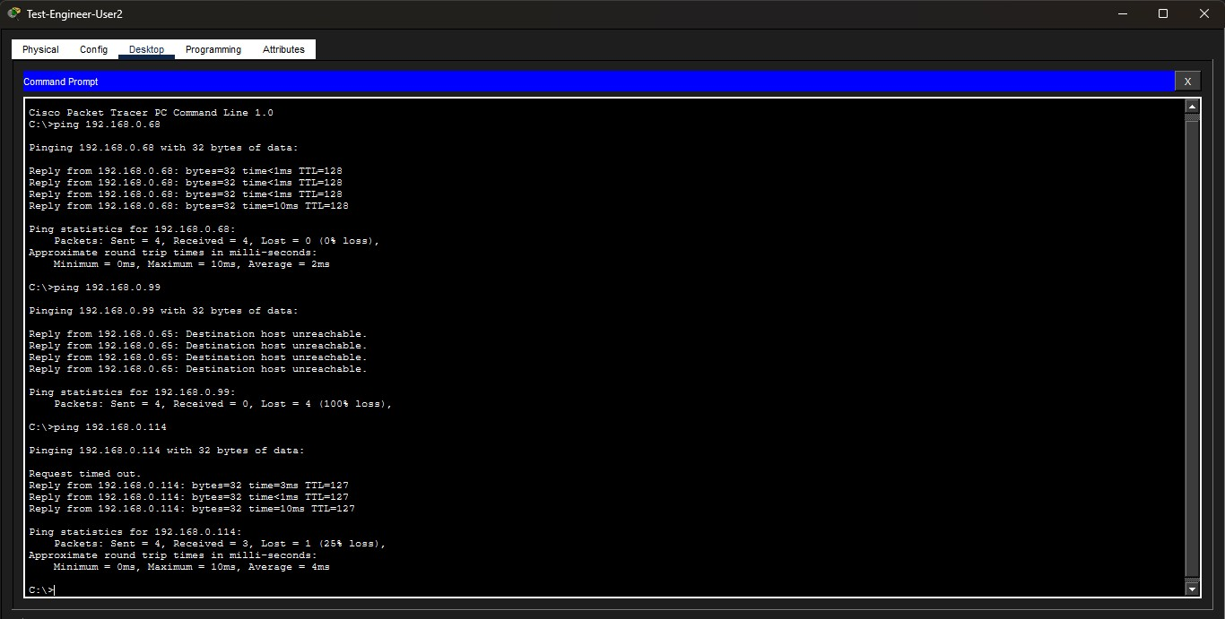

Test engineers can utilize shared resources as shared printer with IP address 192.168.0.114 is reachable as shown above.

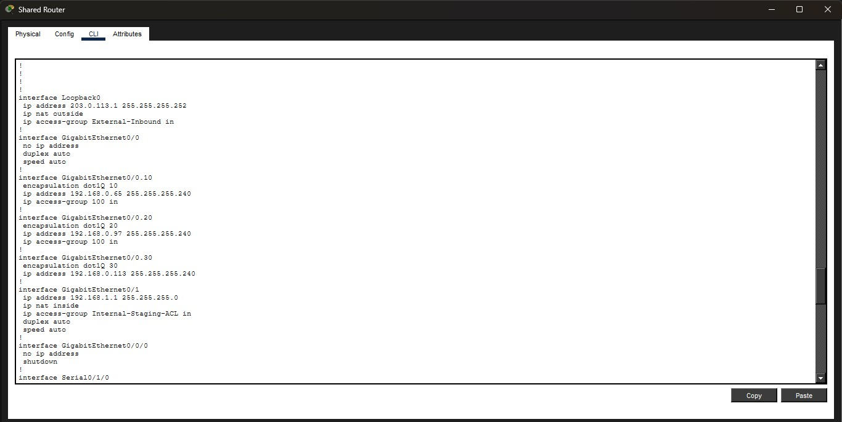

The command show running-config on the router shows that inter-vlan is configured.

2.3)

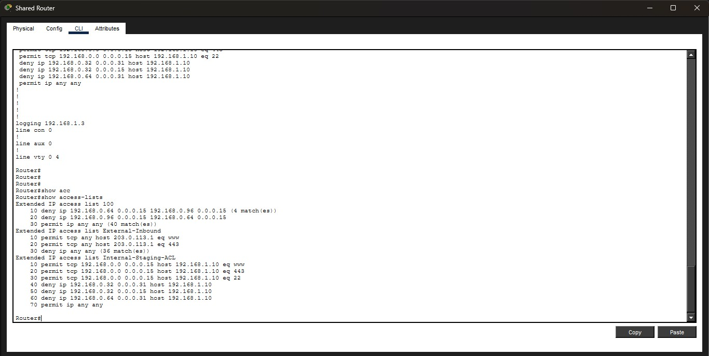

Access-list 100 created as seen above in the shared router settings.



Access-list 100 applied on Vlan 10 an vlan 20 only in-bound as show above.

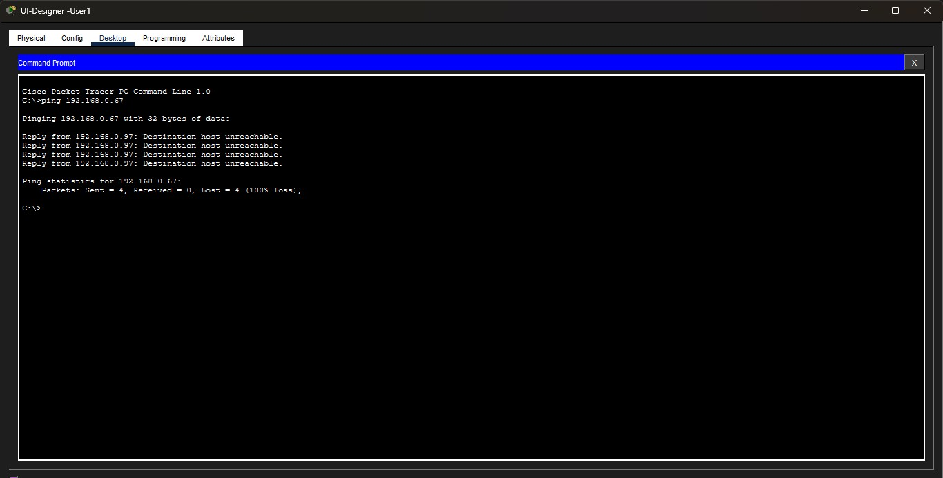

Due to access-list 100 being applied on the vlan interfaces , vlan 10 and vlan 20 cannot communicate.

3.1)

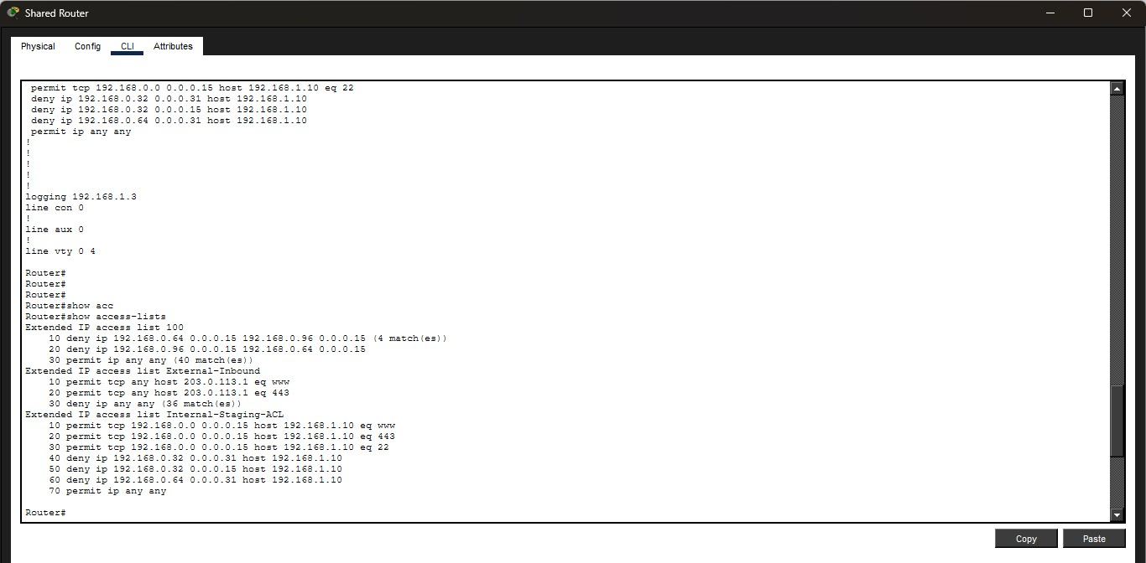

Extended access-list created on the shared router as shown above.

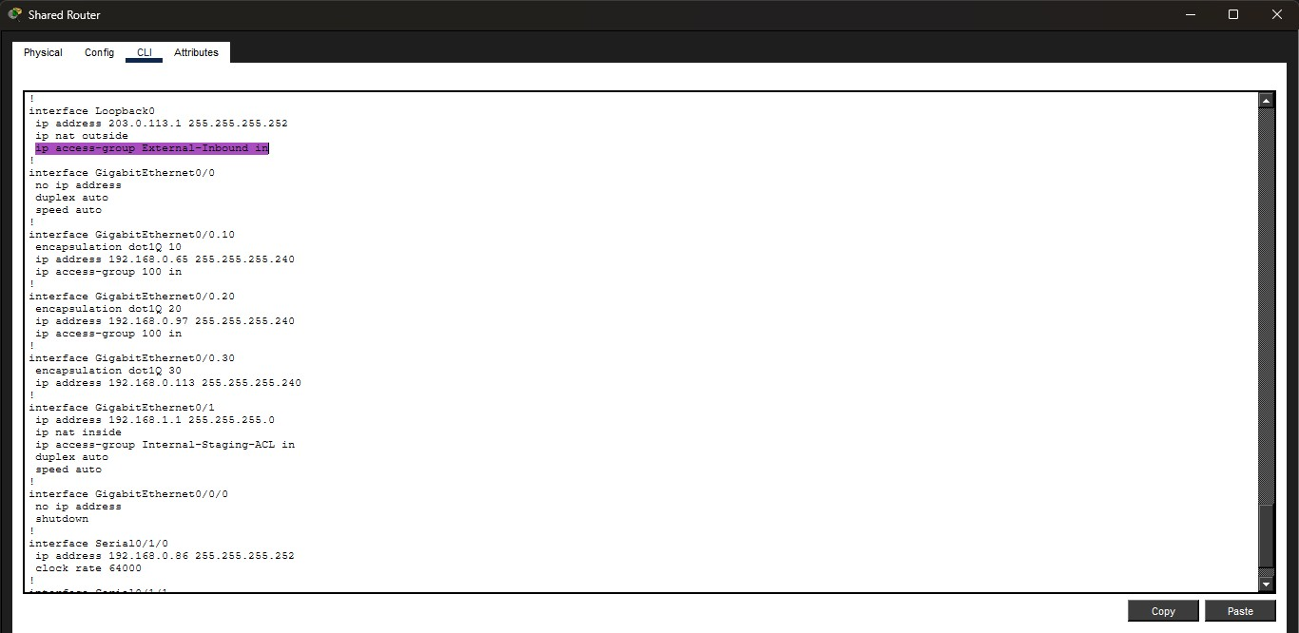
Access-list applied inbound on the ISP connection as it is an external connection (internet).

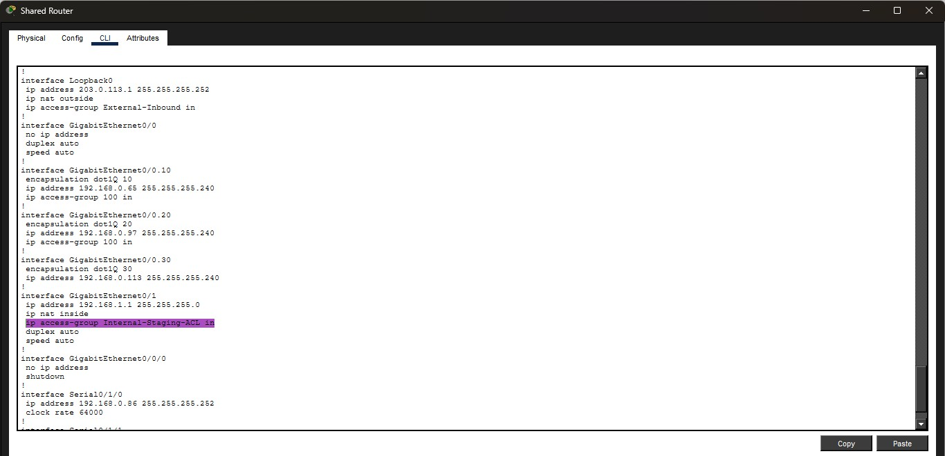
Internal extended access-list applied inbound on the inbound interface gig0/1

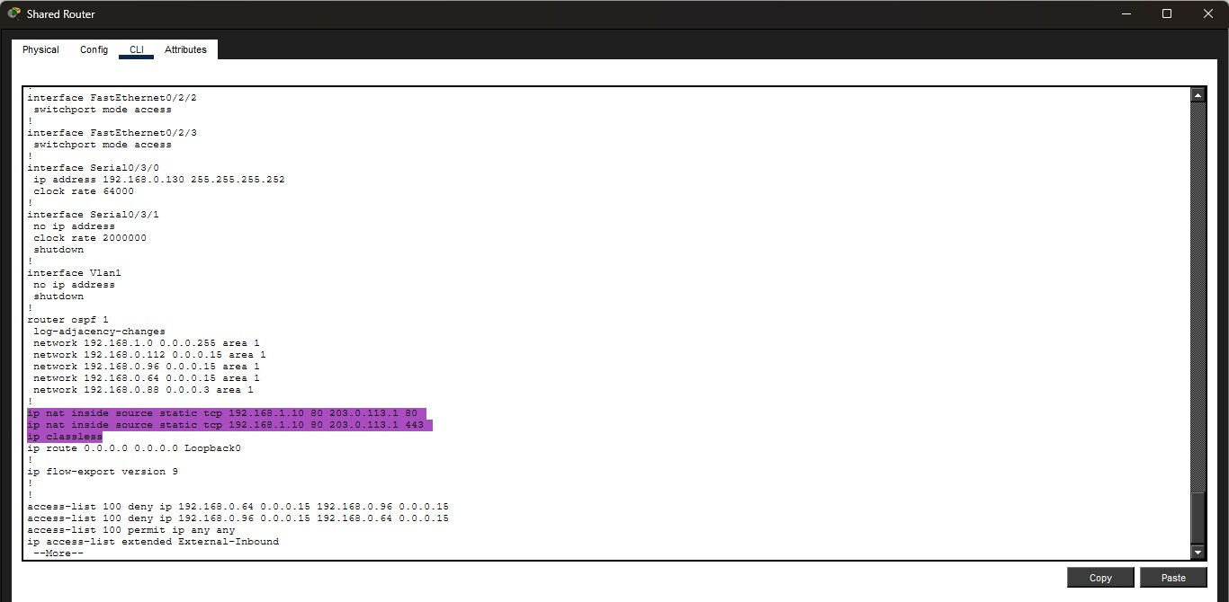

Nat translation settings
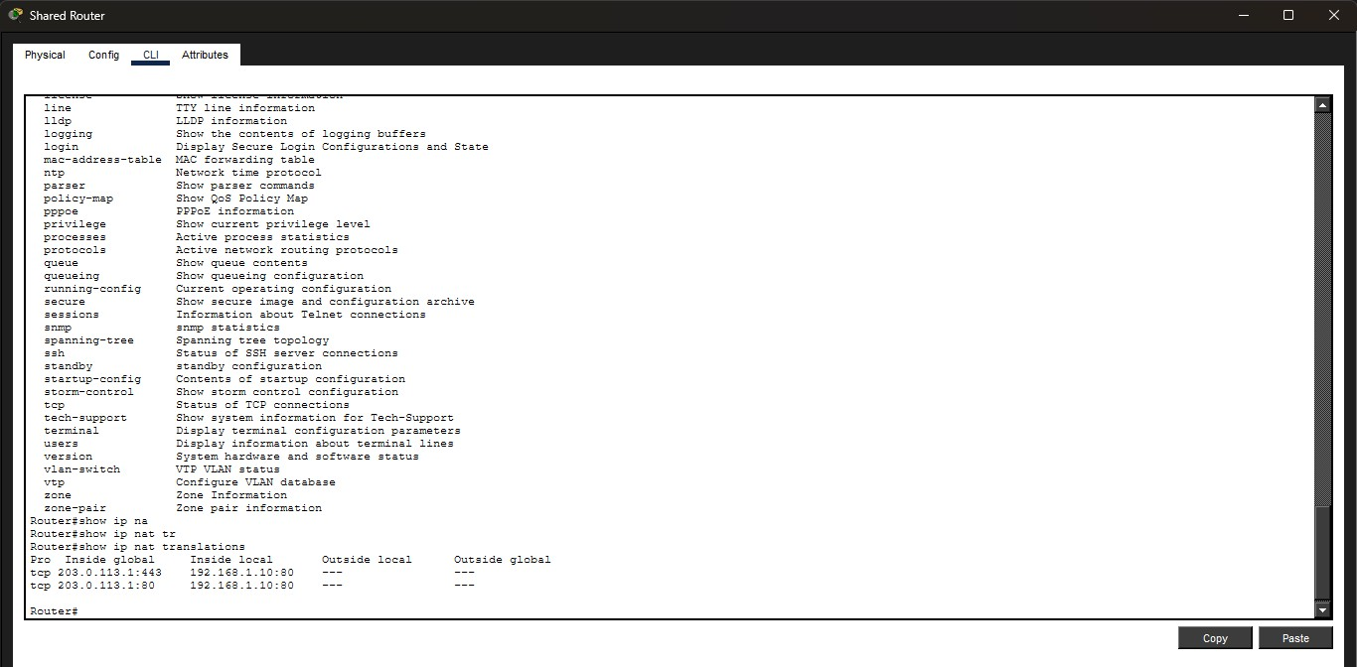

The command show ip nat translations on the shared router shows how the inside global ip address is translated to an inside local ip address as show above.

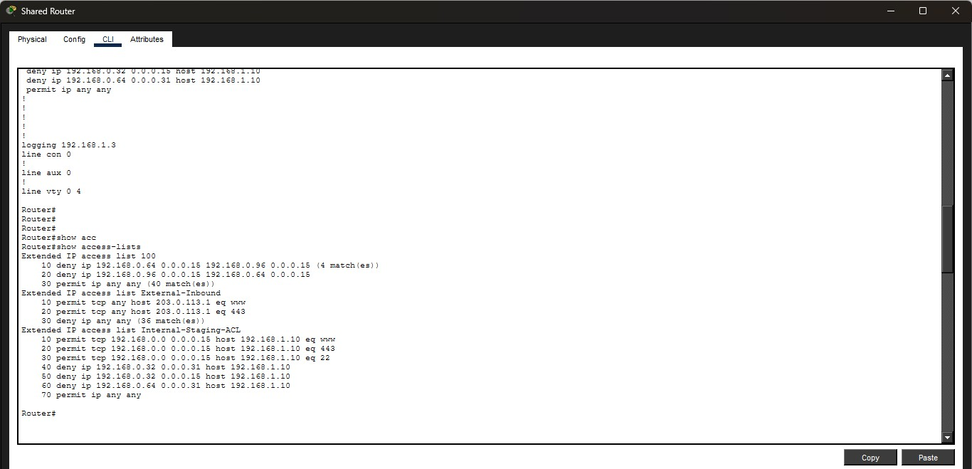

From the above screen shot the extended access-list has 36 deny hits.

3.2) Should the staging server have a DMZ vlan that will help minimize the damage that an attacker can cause on the network as they will not be able to move from host to host willy nilly without being detected as a DMZ vlan will enforce layer 3 screening through an access-list policy. The control plane policy must be setup in such a way that the CPU of router is not over whelmed by corrupted packets that target management interfaces. The control plane policy will regulate the traffic sent to the router’s processor. On the other hand the data plane policy simplifies policy management by using a stateful firewall which can reduce access list statements by just a single permit outbound statement. An access-list will also help by an explicit deny, minimum privilege ordering setup making the policy auditable faster and how one applies the access-list on their interfaces with WANs controlling in-bound traffic from external sources and the LAN controlling traffic initiated internally thus improper placement may risk policy gaps at interfaces. For the DNS a split horizon view should be implemented instead of a single DNS server as with a split horizon DNS different requests get different replies depending on where the query originated. For external users the DNS server should resolve their request to the fire wall’s public WAN while internal users are directed to the server. The use of a SIEM will help record the a sequence of events as it happens innocuous in isolation or a port scan followed hours later by a successful HTTP request followed by an unusual outbound connection can be correlated and flagged.

4.1)

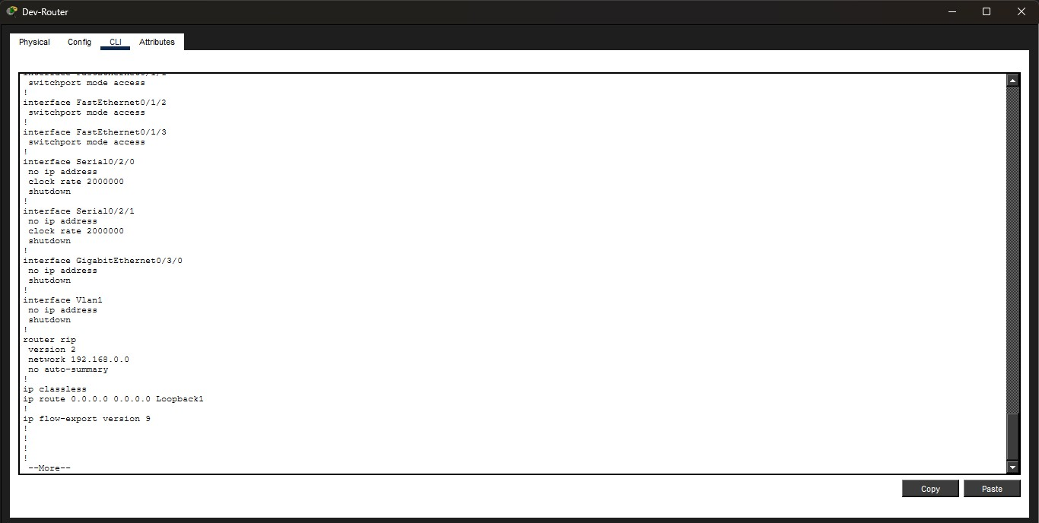

Developers router is running RIP version 2 as seen above.

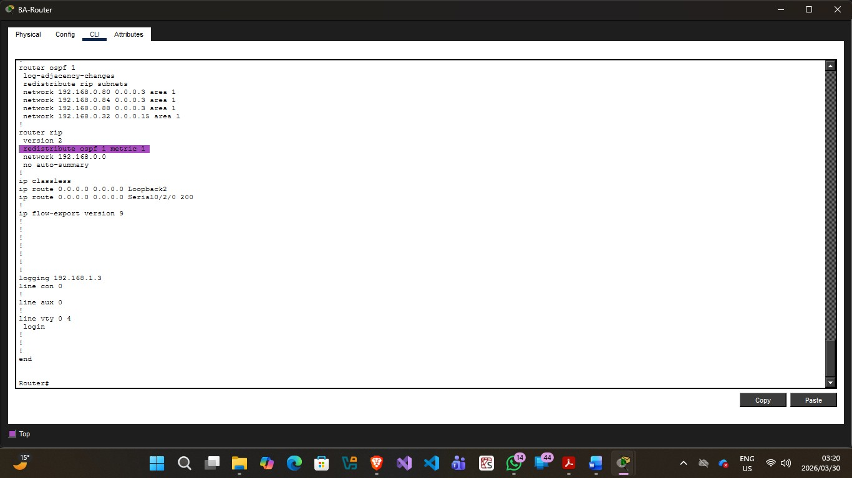

Redistribution of OSPF.

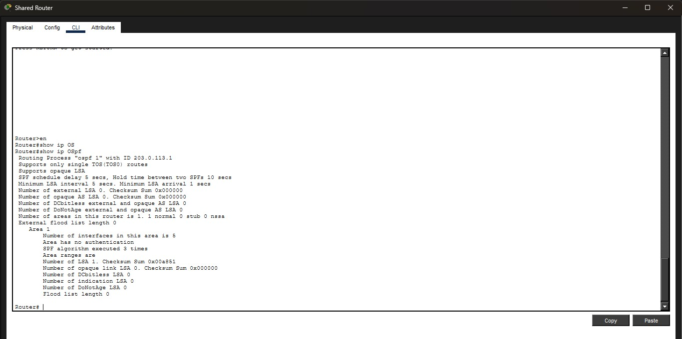

Shared router configured to run OSPF.

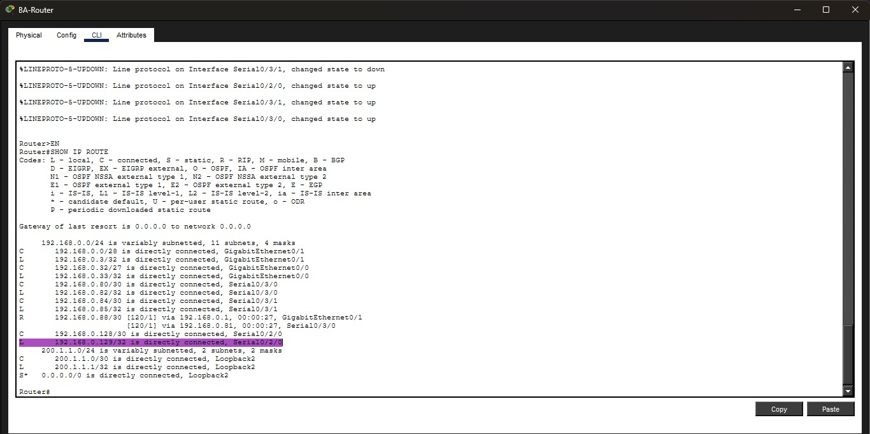

Backup route.

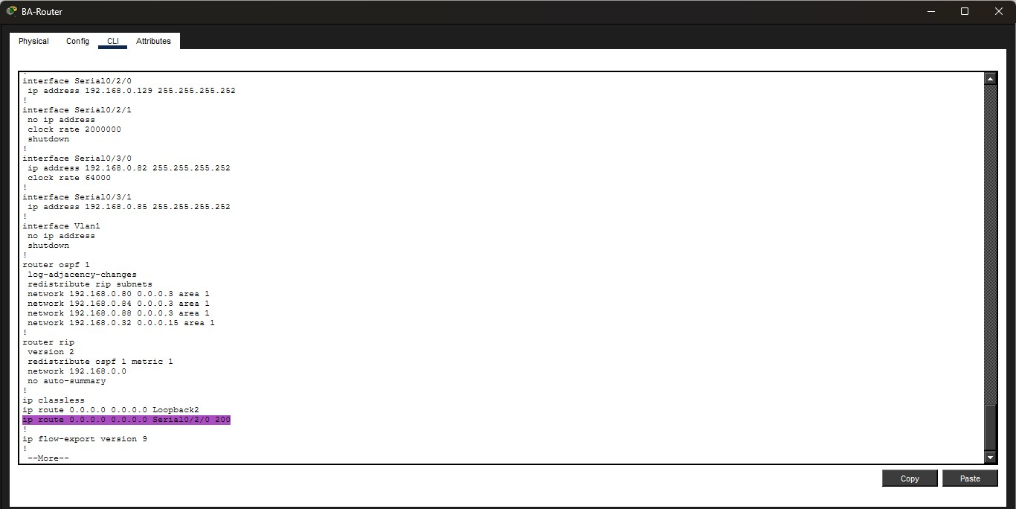

Backup route is implemented by putting a high administrative cost (200) on the backup path thus the router will only select that path only when the main path is totally down.

4.2)

Using both RIP and OSPF in one network can cause problems because they work in different ways. RIP checks how many routers the data passes through by hop count, while OSPF looks at the speed of the connection and cost. Because of this, they don’t understand each other easily. This means devices on one side of the network may not communicate properly with devices on the other side unless extra setup is done.
It also makes the network harder to manage. The people working on the network must learn two different systems, use different commands, and troubleshoot problems in different ways. This takes more time and training, and it increases the chance of mistakes. When RIP and OSPF share routes, more issues can happen, like data moving in circles, slow paths being chosen, or the network becoming unstable. Routers can also become slower because they are doing extra work.

The convergence time of RIP creates a timing mismatch with OSPF’s convergence time making the two incompatible unless additional setup is done. Possible mutual route redistribution of two routers can cause a loop.

The backup link is also affected. OSPF reacts very quickly when there is a problem, but RIP can take up to a few minutes to respond. This means some users may stay connected while others lose connection for a while. The best way to fix these problems is to use only one protocol, like OSPF, because it is faster and easier to manage.

